# Heading 1 [Style Definitions Guidance]

**Do not modify the style definitions in this template.** Add a new style only if necessary.

This is the Normal style. Font is Arial Nova Condensed, which comes with Windows 10 and higher and is also available for free at Microsoft.com.

## Heading 2 [Heading Styles Guidance]

Heading styles in this template are all followed by the Normal style in the next paragraph. Spacing between headings and paragraphs is already set.

Use Headings 1–6 for the main body of the report. Headings 1–3 are listed in the Contents.

### Heading 3 [Table Sample and Guidance]

See a sample table in **Table 1**. Use the Table Title style to automatically include the table title in the List of Tables. Styles are provided for column headers and table cells.

Data/text in all other cells within a column should have the same alignment (for e.g., left, center, right, or decimal).

Table 1. Sample table title in sentence capitalization using the Table Title style

| Table Header | Table Header | Table Header | Table Header | Table Header |
| --- | --- | --- | --- | --- |
| Table Cell (left) | Table Cell (left) | Table Cell (center) | Table Cell (right) | 4.231 |
| Table Cell (left) | Table Cell (left) | Table Cell (center) | Table Cell (right) | 888.56 |
| Table Cell (left) | Table Cell (left) | Table Cell (center) | Table Cell (right) | 0.38 |

Note: Use the Table Notes style for sources or additional info.

#### Heading 4 [Figure Sample and Guidance]

**Figure 1** provides a sample figure. Figure Caption style is automatically included in the List of Figures. Figure Notes style is provided for additional information.

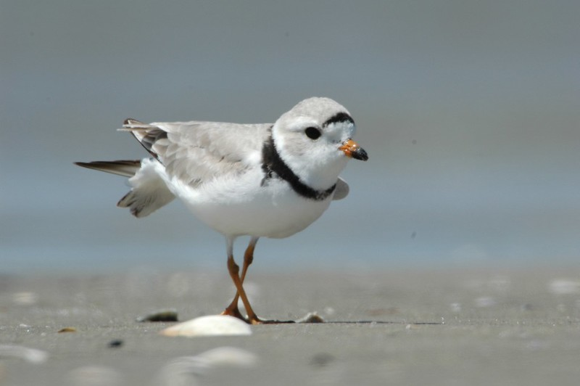

Figure 1. Figure caption in sentence capitalization using the Figure Caption style

Use the Figure Notes style for giving the source or additional info about the figure.

##### Heading 5 [Bulleted List Guidance]

* List Bullet style is default for bulleted lists.
* List Bullet style is default for bulleted lists.
* List Bullet style is default for bulleted lists.

1. Use the Numbered List style for numbered lists.
   1. Use the Numbered List style for numbered lists.
      1. Use the Numbered List style for numbered lists.

# References

[Insert end reference list using the Citation style]

# Appendix A: Title

[Use Heading 1 for appendix headings and use the backspace to delete the section number.]



**U.S. Department of the Interior (DOI)**

DOI protects and manages the Nation's natural resources and cultural heritage; provides scientific and other information about those resources; and honors the Nation’s trust responsibilities or special commitments to American Indians, Alaska Natives, and affiliated island communities.



**Bureau of Ocean Energy Management (BOEM)**

BOEM’s mission is to manage development of U.S. Outer Continental Shelf energy, mineral, and geological resources in an environmentally and economically responsible way.

**BOEM Environmental Studies Program**

The mission of the Environmental Studies Program is to provide the information needed to predict, assess, and manage impacts from offshore energy and marine mineral exploration, development, and production activities on human, marine, and coastal environments. The proposal, selection, research, review, collaboration, production, and dissemination of each of BOEM’s Environmental Studies follows the DOI Code of Scientific and Scholarly Conduct, in support of a culture of scientific and professional integrity, as set out in the   
DOI Departmental Manual (305 DM 3).